Objectives:

* Chapter 10 inheritance.

Inheritance is a process of extending to other classes. Only the main class can run and call the sub classes from the main class.

**There are 3 challenge exercises, each worth 33.3%**

Create a class named c5

Create a class named c6 that extends c5

Create a class named c7 that will call- c5 and then c6

Test the application. Notice that since c6 extends c5 that, c5 gets called first, and then calls c6.

**Project #1**

Create a class without the main method, this will be our sub class.

Create a class with the main method, which we will call out sub class.

Test the application.

**Project #1 continuation**

Have the program enter a name, from the sub class add the following

From the main method call the accessors and mutator

Test the application.

**Challenge Exercise #1:** the program will ask the user to enter the address, city, state, zip code, and grade.

**#1 print screen the output with code from both classes below here.**

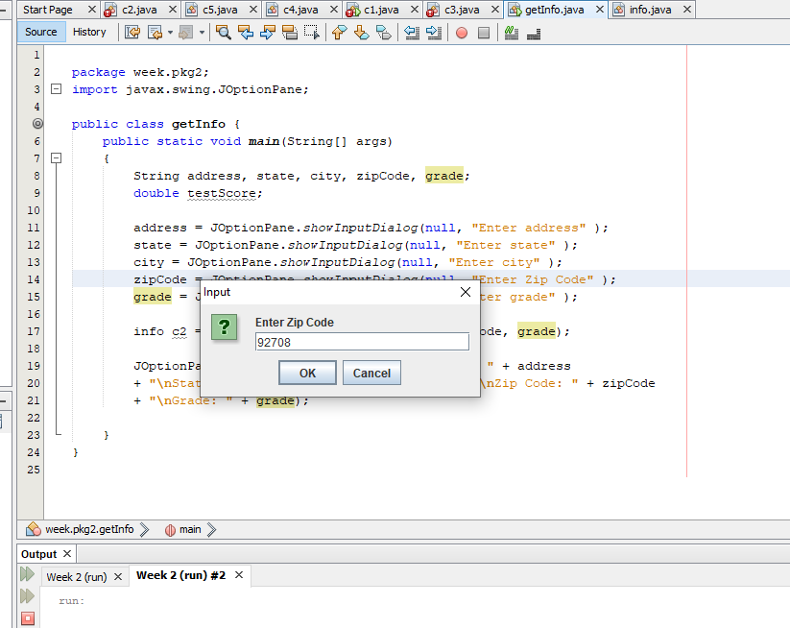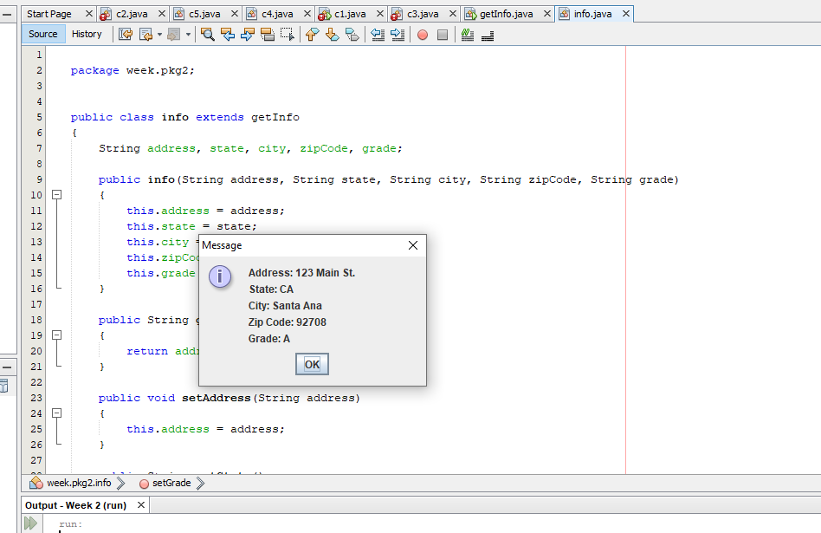

**Project #2**

Use the extends keyword to inherit from the c2 class

Main method

Test the application.

**Delete or comment out the extends keyword and see what happens.**

**Challenge Exercise #2:** Create a JFrame that will allow the user to enter the students last and first name, # of questions attempted and # of questions missed, and get the output. Remember to use the c2 and c3 classes.

**#2 print screen the output with code from all classes below here.**

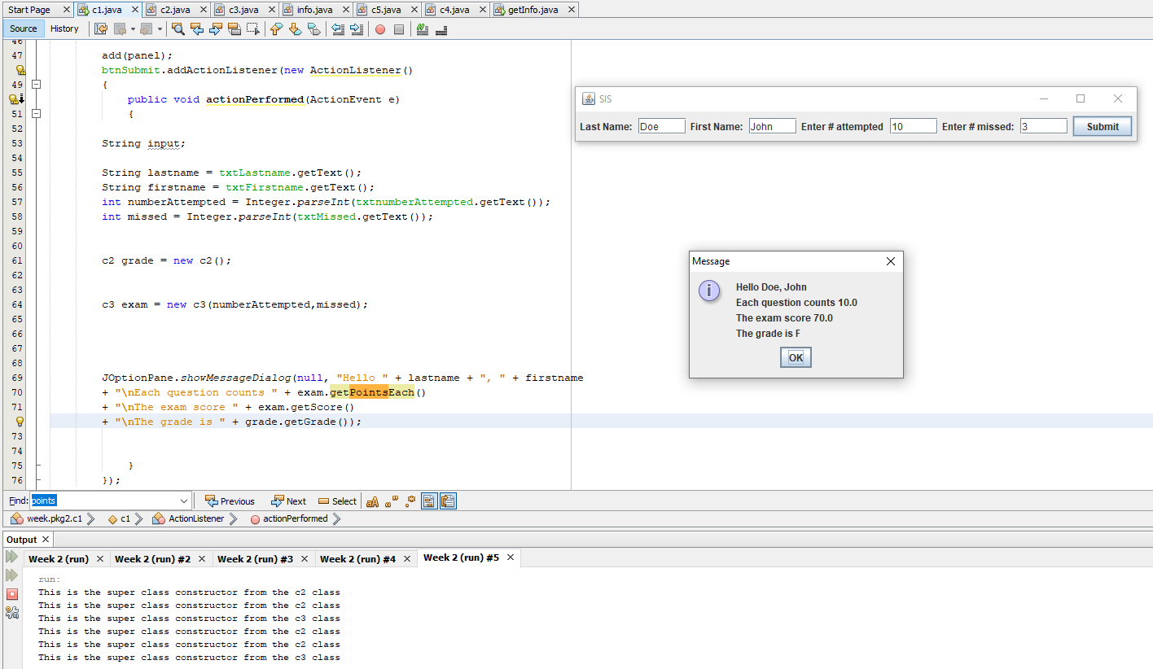

**Project #3**

Get the name, hours worked, hourly pay and retrieve the name and total, use two classes.

Create the class c8

The main method class.

Test the application.

**Challenge Exercise #3:** Continuing with project #3, use an if statement, if the hours worked is over 40 hours than add a 10% to the total.

**#3 print screen the output with code from all classes below here.**

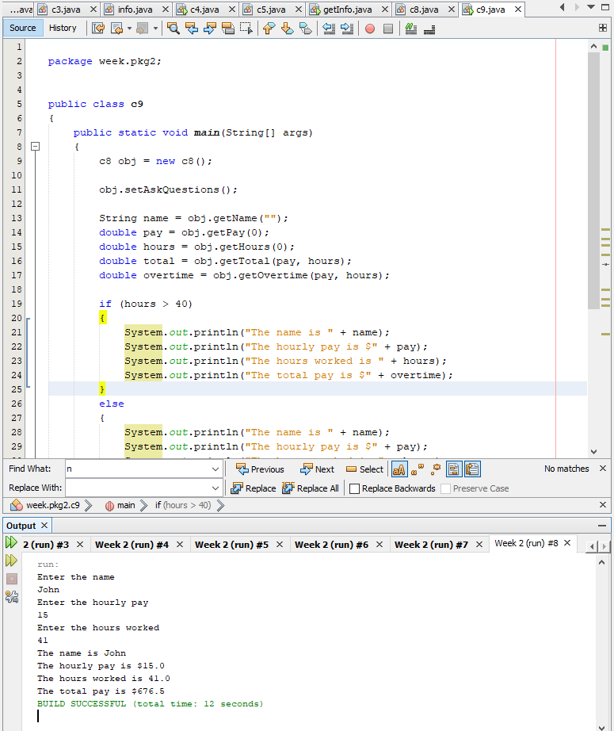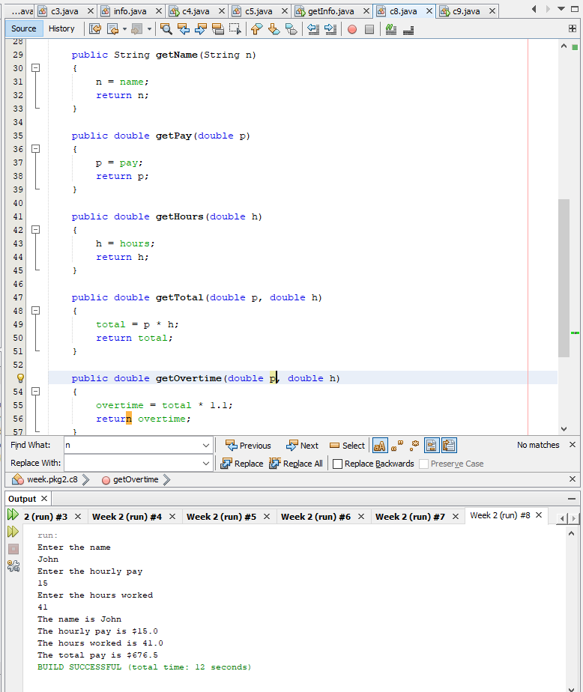

**Submit this document to Module 2 class exercise.**